1. Lab 3. Web Services (JAX-RS) and Spring REST

|  |  |
| --- | --- |
| Goals | Understand the process of creating and Consuming a RESTful Java Web Service |
| Time | 1. minutes |

1. Refer below Java files:

<Product.java>

<ProductDB.java>

Create a Product RESTful web service that will display all products to the Web service consumer.

**Note:** Make use of the static DB given in ProductDB.java

Refer below screen shot:

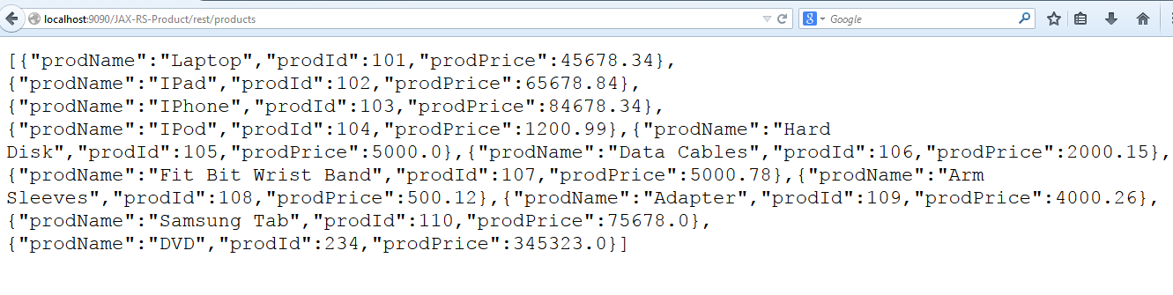

Figure 3 : Screenshot

The consumer should also be able to add a product to the existing list of products.

Refer below screen shots:

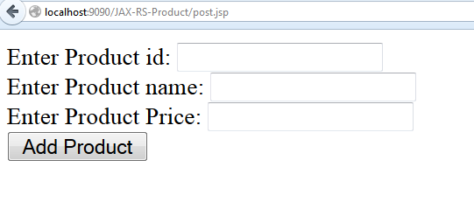

Figure 4 : Input Screen

After entering product details, refer below screen shot

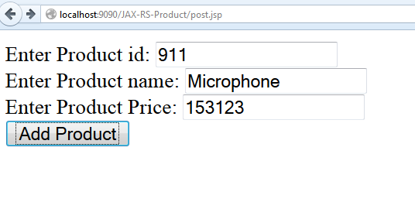

Figure 5 : Input Screen with data

Product is added to existing list of products

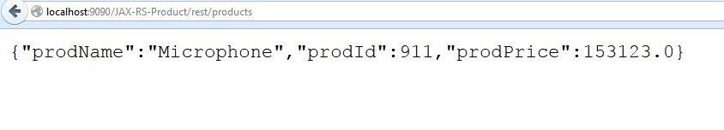

Figure 6 : Screen shot

Now, new product is added to existing list of products

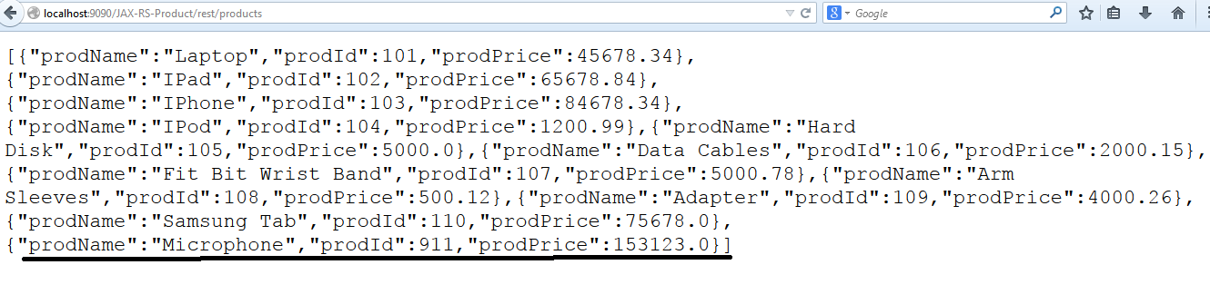

Figure 7 : Screen shot

Refer to the above assignment and create with Spring REST.

1. Spring REST: Exception Handling, Versioning and Pagination

|  |  |
| --- | --- |
| Goals | Understand the process of creating and Consuming a RESTful Java Web Service |
| Time | 1. Minutes |

1. Refer to the Spring REST application created in Lab 2.2. Apply the Exception handling.
2. In Previous lab add the category property in the product class and add the versioning features as new product data will be available with V1 link.

[Hint: Use URI Versioning]